**Program 14: Demonstrate multilevel (3-levels) inheritance using any example hierarchy**

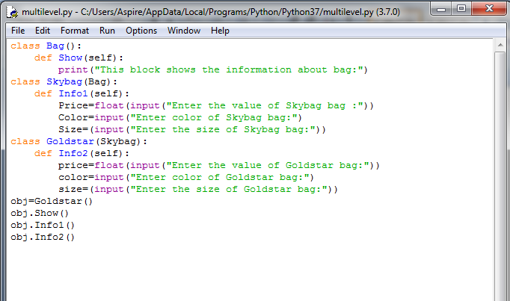

**Output:**

